Table of Contents

1 Portfolio construction 3

1.1 Matching a target portfolio 3

1.1.1 Assumptions: 3

1.1.2 Description 3

1.1.3 Drawbacks 5

1.1.4 Potential Solution 5

1.2 Tilting a target portfolio 5

1.2.1 Current Limitations/What to improve 6

2 Attribution 7

2.1.1 Attribution Calculation Formulas 10

3 Security/Issuer selection 11

3.1 Issuer Filter 11

3.1.1 Financial Risk Metric 11

3.1.2 Results of risk metric and OAS study 12

3.2 Bond Characteristics Filters 12

4 Back-testing 13

4.1 Description of data currently available 13

4.1.1 Index information 13

4.1.2 Financials 13

5 Portfolio Construction – 2 methodologies effect on turnover. 13

5.1 Methodology Description 13

5.2 Back testing results 14

5.3 Observations 15

6 Portfolio Construction – Effect of rebalancing frequency, number of dimensions to Match Index, and use of security/issuer filter. 15

7 Appendix 17

7.1 Appendix A 17

7.2 Appendix B 18

7.3 Appendix C 18

7.4 Appendix D 19

7.5 Appendix E 20

7.6 Appendix F 20

# Portfolio construction

## Matching a target portfolio

### Assumptions:

The list of securities to include in resulting portfolio is a subset of the securities in the target portfolio (i.e. create a subset of securities by filtering out securities from the index universe)

### Description

Given a list of securities, we can construct a portfolio that matches the characteristics of a target portfolio across various dimensions. These dimensions can be categorical (i.e. level 3, currency, country, market weights) or numerical (i.e. securities overall weight across yield, duration, or spread buckets).

The tool assigns each security in the universe to a category/numeric bucket, and then calculates the aggregate market weight within each bucket represented in the universe. Because the list of potential securities is a subset of the universe, some category/numeric buckets may not be present in the filtered list. The tool attempts to match the weight in the buckets of the target portfolio, by reassigning the weight of the buckets present in the target portfolio but not present in the filtered list, to the closest bucket present in the filtered list of securities. Because some category/numerical buckets may be missing entirely after filtering securities out of the universe, and because for numerical buckets we can define a maximum radius over which to look for similar buckets, there is the possibility of not being able to distribute some of the weight in the universe to the buckets represented in the filtered list, and hence the aggregate % market weight in the represented buckets may not add to up 100%; in this case, the tool scales the final weights of every bucket present in the filtered list so that in aggregate they achieve a 100% market weight. To determine the security weights, the tool identifies the filtered securities in each bucket and scales their original market weight so that in aggregate the weights of these securities match the weight of the bucket.

Given categorical labels that describe natural groups and subgroups of securities (i.e. sector and industry classification, or region and country), the user can instruct the tool to attempt to match target portfolio weights from the more specific subgroup to the least specific subgroup (i.e. for a region and country group and subgroup pair, the tool will attempt to match the weights at the more specific country level first, and if it can’t, it will attempt to match the targets overall region weight).

Categories with no specific relation between them can also be specified, and in that case, the tool will attempt to distribute bucket weights across the buckets that match the largest number of categories possible.

The bucketing across a single dimension can be pre-defined by specifying desired bucket edges (i.e to create yield buckets one can predefined the edges of the buckets to be 0%, 1%, 3%, 5%, 10% and 1000%), or the edges can be defined dynamically so that each bucket includes a predefined % market weight of the portfolio. **See FIGURE 1-1.**

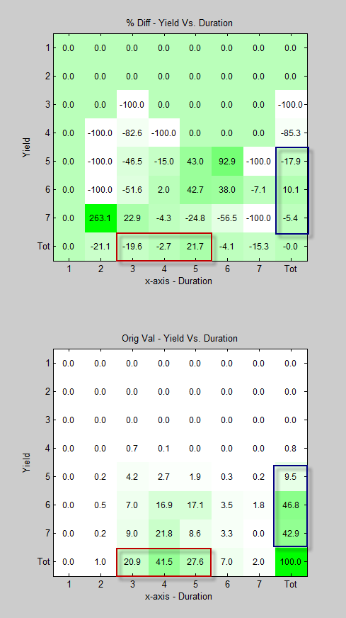

Figure 1-1: Index % market weight decomposition into yield and duration bucket (BOTTOM) and the % difference in market weight between the Index (target portfolio) and the constructed portfolio (after applying issuer/security filter) in each bucket (TOP). In the figure, buckets are numbered, and edges to create buckets are predefined in process.

Notice the bottom row and rightmost column to have totals for % market weight and % difference for each bucket.

### Drawbacks

A high degree of granularity in terms of the category/numeric buckets defined, in tandem with a stringent filtering of securities, can hinder the matching/replication process, by producing a large quantity of buckets that may have no representative securities in the filtered list. Say that you want to replicate the index across the yield, spread and duration dimensions and define 5 buckets across each dimension; this creates a multidimensional space with 125 buckets; given that the index has 1000+ securities, you would expect about 9 securities per bucket if the securities were evenly distributed across the space; but the reality is that there will be a cluster of securities in this space, which will result in a large number of buckets having few or no securities at all.

You can mitigate this by using less granular bucketing (larger buckets), or a less stringent filtering (more securities). Less granular bucketing can lead to poor matching of the target portfolio characteristics, and a less stringent filtering can lead to a large number of securities which makes it impractical to construct the replicating portfolio.

An ideal solution would provide a balance between the number of buckets used and the number of securities in the filtered list so as to obtain a viable portfolio that accurately matches the target portfolio.

### Potential Solution

One potential solution is to bucket the target portfolio, and then filter securities within each bucket. In buckets with few securities, the filter could be less stringent, and in buckets with many securities, the filter could be more stringent; the goal being to end up with a manageable number of securities in the constructed portfolio, to ensure that the buckets with weight in the target portfolio are all present in the constructed portfolio, and to ensure there are enough securities in each bucket so that their % market weight in the replicating portfolio was not greater than a previously determined amount.

To achieve the above an iterative process could be set up to gradually relax the securities filter so as to increase the number of securities within each bucket. The process could stop when there were enough securities so their individual weight would not be greater than a predefined amount (initially we could simplify the process by assuming the securities in each bucket would be equally weighted).

How to dynamically create more buckets in regions of the multidimensional space where the target portfolio has more market weight and/or securities is open to question. Maybe an adaptation of a clustering algorithm could assist in identifying regions in multidimensional category/numeric space with high % market weight density. Identifying these clusters might assist us in identifying buckets we would like to be careful in replicating.

## Tilting a target portfolio

The construction tool allows the user to specify ‘tilts’ across numerical category buckets relative to the target portfolio (i.e you can specify to overweight/underweight the bucket of securities with duration in the 5-7yrs range). You can specify tilts across multi-dimensional buckets (i.e. bucket of securities with duration in the 5-7 yrs bucket, and yield in the 7-9% bucket. You can specify multiple tilts (i.e. one tilt over a bucket of securities with duration less than 1yr and a second tilt over a bucket of securities with duration more than 7yrs).

Once a tilt in a numeric characteristic is defined, the buckets not included in that tilt will be affected as the overweight/underweight in the target bucket implies an underweight/overweight in the other buckets (i.e. a tilt of 10% in the 5+yrs duration bucket, would imply a 10% underweight in the 0-5yrs duration bucket). **See FIGURE 1-2.**

### Current Limitations/What to improve

* Currently it is only possible to specify tilts across numerical categories.
* If multiple tilts are specified, there should be no overlap between the bucket each tilt specifies (i.e. specifying a 10% overweight of the 10+ duration bucket, along with a 10% overweight in the “10+ duration/10+ yield” bucket, would create an approx. overweight of 21% in the “10+ duration/10+yield” bucket).

# Attribution

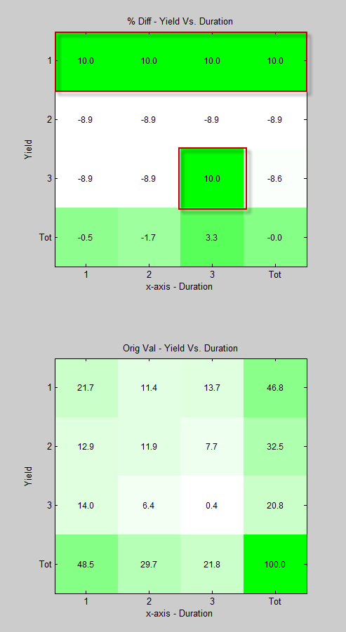

Figure 1‑2: Index % market weight decomposition into yield and duration buckets (BOTTOM) and the % difference in market weight between the Index (target portfolio) and the tilted portfolio (no issuer/security filter is being applied here) in each bucket (TOP). In the figure, buckets are numbered, and in this case the edges to create buckets were determined so that each bucket contributed 33% of the overall portfolio yield (for the yield buckets), and duration (for the duration buckets).

Notice the bottom row and rightmost column to have totals for % market weight and % difference for each bucket.

The modification in this example involves a 10% overweight of the 1st yield bucket (the securities with lowest yields), and a 10% overweight in the intersection of the 3rd yield and 3rd duration bucket (the securities with highest yields and durations).

User can decompose a security or group of securities total return, into its income component, duration component and spread component. Given a benchmark and a constructed portfolio, an additional selection effect component can be calculated. The income, duration, or spread return components can each be further decomposed into a sector and selection component to determine the contribution to returns of the manager’s sector allocation and issuer selection.

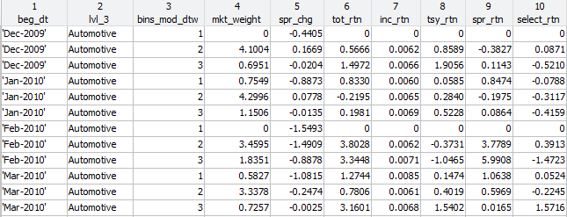The attribution can be performed across user defined buckets. These buckets can be specified to be any combination of categorical characteristics (i.e. level 3 industry classification, asset class, currency, country, etc) and buckets of numerical characteristics (i.e. duration, yield, spread).

Figure 2-1: This screenshot shows the returns of the Automotive sector bucketed by modified duration to worst (column 3) for the period Dec-2009 to March 2010 for a portfolio constructed after filtering issuers/securities from the Index portfolio at each of these months. Total, income, treasury (duration) spread and issue selection return are in columns 6, 7, 8, 9 and 10 respectively.

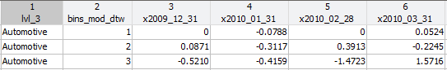

Figure 2-2: For a portfolio constructed after filtering out securities and issuers, this screenshot shows the tabulated selection effect returns of the securities in the Automotive sector bucketed by duration to worst.



Figure 2-3: Cumulative total returns for period 2009/12/31 to 2011/01/31 for the Index Vs. a portfolio constructed by filtering out securities and issuers from the index and then adjusting the remaining security weights to match the portfolio characteristics.



Figure 2-4: Cumulative treasury (top left), income (top right), spread (bottom left) and selection returns (bottom right) for the Index Vs. a portfolio constructed by filtering out securities and issuers from the index and then adjusting the remaining security weights to match the portfolio characteristics.

### Attribution Calculation Formulas

Given beginning of the month coupon, spread duration and price; and monthly total return and excess returns.

#### For portfolio – No benchmark

Income_return = current_couponbom / pricebom / 12;

Tresaury_return = (1 + total_return) / (1 + excess_return) -1

Spread_return = (1 + excess_return) / ( 1 + income_return) – 1

Spread_changeest = -1 x Spread_return / Spread_durationbom

#### For portfolio - given a bench/target portfolio

Income_return = current_couponbom / pricebom / 12;

Tresaury_return = (1 + total_return) / (1 + excess_return) -1

Spread_changeest port = Spread_changeest ench

Spread_returnest = -1 x Spread_changeest bench  x Spread_durationbom

Selection_return = [(1 + excess_return) / [( 1 + income_return) x (1 + Spread_returnest)]) – 1

# Security/Issuer selection

## Issuer Filter

Given an issuer financial risk metrics, where higher risk is associated with a higher number, we rank issuers within their peer group and exclude the issuers that belong in a particular upper percentile.

A peer group is currently defined as issuers that belong to a particular level 3 industry classification for a given date.

### Financial Risk Metric

This metric is applied to industrials and utilities issuers, not to financial companies.

Each issuer is assigned a risk metric relative to a group of peers. The peer group is currently being defined as issuers that belong to the same level 3 industry classification for a given date.

This risk metric is calculated using the issuer’s ranking in various financial metrics, and using the intuitive relationship between each financial metric and credit risk. A higher overall risk metric value is considered a higher credit risk.

Currently the financial metrics considered are: Net Debt, Total Assets, Interest Coverage, Total Leverage, and Senior Debt Percentage.

Given the following variables:

rNDi = rank of security ‘i’ with regards to Net Debt.

rTAi = rank of security ‘i’ with regards to Total Assets.

rICi = rank of security ‘i’ with regards to Interest Coverage.

rTLi = rank of security ‘i’ with regards to Total Leverage.

rUDPi = rank of security ‘i’ with regards to Unsecure Debt Percent of Total Debt.

the current formulas to calculate a security overall risk ranking among its peers are:

Formula 1: riskMetrici = rND - rTAi - rICi + rTLi - rUDPi

Formula 2: riskMetrici = rND - rTAi - rICi + rTLi

where we consider a higher value to correspond to higher credit risk.

### Results of risk metric and OAS study

#### Including rUDPi (Unsecure Debt Percent of Total Debt)

* The mean 3 month selection return of issuers with high OAS and low risk value is greater than the return of the issuers with low OAS and high risk value.
* The median 3 month and 6 month selection return of issuers with high OAS and low risk value is greater than the return of the issuers with low OAS and high risk value.
* The median 3 month and 12 month selection return of issuers with high OAS and low risk value is greater than the return of the average of all issuers.

#### Not Including rUDPi (Unsecure Debt Percent of Total Debt)

* The mean 3 month selection return of issuers with high OAS and low risk value is greater than the return of the issuers with low OAS and high risk value.
* The median 3 month and 12 month selection return of issuers with high OAS and low risk value is greater than the return of the issuers with low OAS and high risk value.
* The median 3 month selection return of issuers with high OAS and low risk value is greater than the return of the average of all issuers.

**Possible Flexibility**: For the issuers within a peer grouping, the sign of the cross sectional correlation between a proxy for credit risk (i.e. security OAS) and any financial metric could be used to derive the sign in front of the corresponding financial metric ranking in the formula above.

See **Appendix A and B**, for a list of available financial metrics and security metrics available.

See **Apendix C** for statistics on quantity of issuers with financial data.

## Bond Characteristics Filters

Industries: Using bloomberg’s industry classification for granularity, securities in certain industries are excluded. Refer to **Appendix D** for current list of industry exclusion.

Face Value: At each evaluation date, exclude bonds with a face value in the lower 25th percentile. Table in **appendix E** contains 25th percentile face value size for the index at various points in time.

Price: Within each Merrill level 3 industry, exclude the lowest and highest quartile priced bonds.

Political Risk: Use Develop/Emerging as a proxy for high political risk, and filter out emerging market bonds.

# Back-testing

The system has back testing capabilities that allow the user to examine the effect on returns due to security/issuer selection methodologies, portfolio construction/replication methodologies and the effect of portfolio tilting through time.

## Description of data currently available

### Index information

Merrill H0A0 monthly constituent characteristics and returns information starting in 1998 up to December 2012. We can easily gather missing monthly information up to prior month.

### Financials

Information starting from 1997 and ending in December 2012. It is only until 2002 that the issuers with financials available account for more than 50% of the market weight of the H0A0, and it is only until 2005 that the database has information for more than 50% of the issuers in the index. See **Appendix C** for statistics on quantity of issuers with financial data, and % of market weight in the index that these issuers represent.

# Portfolio Construction – 2 methodologies effect on turnover.

## Methodology Description

|  |  |  |
| --- | --- | --- |
|  | **Basic Scaling** | **Constant par amount** |
| 1. | Every month a new list of potential securities is selected from the current index holdings by filtering out issuers based on mkt weighted ‘OAS’ and an issuer credit metric. | Every month a new list of potential securities is selected from the current index holdings by filtering out issuers based on mkt weighted ‘OAS’ and an issuer credit metric.  This list of potential securities is merged with the list of securities used during the prior month. |
| 2. | Index structural characteristics are matched by matching the index weights across ‘OAS’, ‘YTW, and ‘Eff Dur’ buckets. | Index structural characteristics are matched by matching the index weights across ‘OAS’, ‘YTW, and ‘Eff Dur’ buckets. |
| 3. | Weights of the filtered securities belonging to each bucket are scaled so their aggregate weight matches their bucket’s weight. | A par amount to use for all securities is predefined. Given this predefined par amount, enough securities belonging to each bucket are selected to match the bucket market weight. When selecting securities, precedence is given to securities with higher ‘OAS’ and to securities present in the prior portfolio. |
| 4. | The par amount of each security is derived from its market weight and its price including accrued interest. | The market weight of each security is derived from the predefined par amount and price including accrued interest. |

## Back testing results

|  |  |  |  |  |
| --- | --- | --- | --- | --- |
| **Time Period** | 2000-01-31 to 2013-01-31 | | | |
| **Rebalancing** | Monthly | | | |
| **Portfolio Construction Method** | **Basic Scaling** | | **Constant par amount** | |
|  | **Mean** | **Std Dev** | **Mean** | **Std Dev** |
| **Portfolio Turnover /year 1,2** | 523% | 32% | 209% | 19% |
| **Trading Cost /month 1,3** | 43 bps | 7 bps | 25 bps | 5 bps |
| **Number of issuers** | 210 | 35 | 164 | 24 |
| **Number of securities** | 266 | 43 | 209 | 39 |
| **Max security face** | 3.9 | 2.2 | 0.5 | 0 |
| **Min security face** | 0.10 | 0.03 | 0.5 | 0 |
| **Max security weight** | 3.5% | 1.6% | 0.58% | 0.09% |
| **Min security weight** | 0.07% | 0.02% | 0.30% | 0.17% |
| **Performance** | Cumulative total return and cumulative decomposed returns (income, duration, spread, and selection) over the entire period show no significant difference (See appendix 6.6).  Construction methodology seems to be able to cause significant differences in cumulative selection return as can be observed during the 2002-2003 period (See appendix 6.6). | | | |

1. Rebalancing occurs monthly.
2. Minimum of aggregate LTM market value of purchases or aggregate LTM sales, divided by average monthly NAV of account.
3. A 1% charge is applied to all buys implying you buy at “Ask” price and immediately lose 1% since securities are priced at “Bid”. When selling, you sell at “Bid” price so presumably you have no trading cost.

|  |  |  |  |  |
| --- | --- | --- | --- | --- |
| **Time Period** | 2000-01-31 to 2013-01-31 | | | |
| **Rebalancing** | Every 4 months | | | |
| **Portfolio Construction Method** | **Basic Scaling** | | **Constant par amount** | |
|  | **Mean** | **Std Dev** | **Mean** | **Std Dev** |
| **Portfolio Turnover /year 1,2** | 225% | 12% | 100% | 12% |
| **Trading Cost /month 1,3** | 18 bps | 0.32 | 7 bps | 13 bps |
| **Number of issuers** | 201 | 32 | 153 | 28 |
| **Number of securities** | 254 | 41 | 195 | 40 |
| **Max security face** | 3.86 | 1.86 | 0.55 | 0.15 |
| **Min security face** | 0.05 | 0.02 | 0.55 | 0.15 |
| **Max security weight** | 3.61% | 1.42% | 0.62% | 0.15% |
| **Min security weight** | 0.04% | 0.01% | 0.28% | 0.15% |

## Observations

1. The two methodologies explored represent 2 potential extremes, and I would expect combinations of these methodologies to yield results somewhere in between the results of each
2. The methodology “Basic scaling” leads to higher turnover and trading costs than the methodology of maintaining “Constant security par amounts”.
3. “Basic scaling” portfolios can lead to more implementation and maintenance work. Basic scaling leads to higher number of issuers and securities, and a bigger range of securities market weight. The higher the number of issuers, the more work is spent following the companies. The more securities in the portfolio, the more work for traders to initially invest the accounts cash, and potentially more work for traders to handle cash inflows and outflows.
4. Basic portfolio scaling has no control over minimum and maximum security weights, which can lead to undesirably high issuer/security positions or irritatingly small positions to trade.
5. Rebalancing significantly decreased both portfolio turnover and trading costs.

# Portfolio Construction – Effect of rebalancing frequency, number of dimensions to Match Index, and use of security/issuer filter.

|  |  |
| --- | --- |
| **low rebal freq** | **high rebal freq** |
| increase index matching dimensions | reduce index matching dimension |
| reduce iss/sec filters | reduce iss/sec filters |

Security/Issuer filter does not seem to be a driving factor of performance.

# Appendix

## Appendix A

|  |  |
| --- | --- |
| **Financial Metrics Available** |  |
| NetDebt | LTDIncCapLease1yr |
| TotalDebt | LTDIncCapLease2yr |
| TotalAssets | LTDIncCapLease3yr |
| NetLeverage | LTDIncCapLease4yr |
| NetLevCapexAdj | LTDIncCapLease5yr |
| IntCoverage | LTDIncCapLeaseWithin5yr |
| IntCoverageCapexAdj | LTDIncCapLeaseAfter5yr |
| EBITDA | Total BondDebt AsPercentOfTotalDebt |
| EBITDACapexAdj | Total CommercialPaper AsPercentOfTotalDebt |
| Capex | Total SeniorDebt AsPercentOfTotalDebt |
| InterestExpense | Total SeniorBondsNotes AsPercentOfTotalDebt |
| CashFromFinancing | SrSecLoans AsPercentOfTotalDebt |
| CashFromInvesting | SrSecBond AsPercentOfTotalDebt |
| CashFromOperations | Total UnsecDebt AsPercentOfTotalDebt |
| TotalRevenue | SrUnsecBond AsPercentOfTotalDebt |
| OperatingIncome | CapLease AsPercentOfTotalDebt |
| NetIncome | Total ConvDebt AsPercentOfTotalDebt |
| GrossMargin | OtherBorrow AsPercentOfTotalDebt |
| OperatingMargin | BookValueCommonEquity |
| EBITDAMargin | Total CP |
| TotalLeverage | Total RevCredit |
| TotalLevCapexAdj | Total TermLoan |
| NetRentalExpense | Total SrBondNotes |
| CashAndEquiv | Total SubBondNotes |
| CurrentAssets | Total TrustPfd |
| CurrentLiabilities | CapLeases |
| WorkingCapital | OtherBorrowings |
| NetWorkingCapital | PrincipalAmtDebtOutstanding |

** ‘Specific Debt Type’ as % of Total Debt is a number based on an amount of that type of debt (i.e. senior bonds, or secured bonds, etc) aggregated across all entities belonging to an issuer.

*** Most of the time the financial data belongs to the ultimate parent of a security, and not to the immediate entity that issued the security.

## Appendix B

|  |  |  |  |  |
| --- | --- | --- | --- | --- |
| **Bond Metrics** |  |  |  |  |
| cur_cpn | ytm | ytw | oas | tot_rtn |
| mat_dt | mod_dur | eom_ytw | eom_oas | excess_rtn |
| face_val | cvx | mod_dtw | eff_yld | excess_swap_rtn |
| price | spr_dur | eom_mod_dtw | eom_eff_yld |  |
| eom_price |  | yrs_tw | eff_dur |  |
| rating_weight |  | ctw | eom_eff_dur |  |
|  |  | eom_ctw | eff_cvx |  |
|  |  | stw |  |  |
|  |  | eom_stw |  |  |

*** eom = end of month

*** rtn = returns (month to date)

## Appendix C

|  |  |  |  |  |
| --- | --- | --- | --- | --- |
| **beg_dt** | **num_issuers**  **in H0A0** | **Issuers for which there is financial data** | **Percent of issuers with financial Data** | **Percent market weight issuers with financial Data** |
| 12/31/2012 | 1165 | 623 | 53% | 64% |
| 12/31/2011 | 1084 | 637 | 59% | 65% |
| 12/31/2010 | 1164 | 625 | 54% | 61% |
| 12/31/2009 | 1012 | 570 | 56% | 63% |
| 12/31/2008 | 978 | 559 | 57% | 63% |
| 12/31/2007 | 985 | 602 | 61% | 66% |
| 12/31/2006 | 1000 | 616 | 62% | 65% |
| 12/31/2005 | 1017 | 560 | 55% | 63% |
| 12/31/2004 | 1067 | 479 | 45% | 65% |
| 12/31/2003 | 1110 | 369 | 33% | 58% |
| 12/31/2002 | 1071 | 272 | 25% | 51% |
| 12/31/2001 | 925 | 172 | 19% | 47% |
| 12/31/2000 | 1009 | 134 | 13% | 34% |
| 12/31/1999 | 852 | 93 | 11% | 31% |
| 12/31/1998 | 1016 | 27 | 3% | 6% |
| 12/31/1997 | 904 | 9 | 1% | 4% |

## Appendix D

Bloomberg Industries currently excluded from portfolio.

|  |  |  |
| --- | --- | --- |
| Internet- B2B/E-Commerce | Retail- Multilevel Dir Selling | Health Prod- Dental Supplies&Equip |
| Internet- E-Commerce/Products | Retail-Appliances | Health Prod- Diagnostic Equipment |
| Internet Connectiv Svcs | Retail-Arts&Crafts | Health Prod- Disposable Medical Prod |
| Internet Content-Info/Ne | Retail-Auto Parts | Health Prod- Health care Safety Device |
| Internet Infrastr Equip | Retail-Bedding | Health Prod- Medical Imaging Systems |
| Internet Infrastr Sftwr | Retail-Bookstore | Health Prod- Respiratory Prod |
| Internet Security | Retail-Building Products | Health Serv- Medical-HMO |
| Internet- Web Hosting/Design | Retail-Catalog Shopping | Health Serv- Medical-Nursing Homes |
| Internet- Web Portals/ISP | Retail-Computer Equip | Health Serv- Medical-Outptnt/Home Med |
| Computers- Memory Devices | Retail-Consumer Electron | Health Serv- MRI/Medical Diag Imaging |
| Semiconductors- Compo-Intg Circu | Retail-Convenience Store | Health Serv- Phys Practice Mgmnt |
| Software- Communications Software | Retail-Fabric Store | Health Serv- Phys Therapy/Rehab Cntrs |
| Software- Computer Graphics | Retail-Floor Coverings | Pharma- Drug Delivery Systems |
| Software- Computer Software | Retail-Gardening Prod | Pharma- Medical-Whsle Drug Dist |
| Software- Decision Support Softwar | Retail-Home Furnishings | Pharma- Therapeutics |
| Software- Educational Software | Retail-Hypermarkets | Pharma- Veterinary Diagnostics |
| Software- Entertainment Software | Retail-Jewelry |  |
| Software- Medical Information Sys | Retail-Leisure Products |  |
| Software- Transactional Software | Retail-Misc/Diversified |  |
| Apparel- Footwear&Related Apparel | Retail-Music Store |  |
| Apparel- Intimate Apparel | Retail-Office Supplies |  |
| Apparel- Textile-Apparel | Retail-Perfume&Cosmetics |  |
| Distribution/Wholesale | Retail-Pet Food&Supplies |  |
| Electric- Transmission | Retail-Petroleum Prod |  |
| Gas- Transportation | Retail-Sporting Goods |  |
| Water- Water | Retail-Toy Store |  |
|  | Retail-Video Rental |  |
|  | Retail-Vision Serv Cntr |  |
|  | Retail-Vitamins/Nutr Sup |  |

## Appendix E

Index face value percentiles at various points in time.

|  |  |  |  |  |  |
| --- | --- | --- | --- | --- | --- |
| **beg_dt** | **Number of Securities** | **face value 25 ptile (MM)** | **face value median (MM)** | **face value 75 ptile (MM)** | **face value max (MM)** |
| 8/31/2013 | 2193 | 275 | 400 | 650 | 3312 |
| 12/31/2012 | 2112 | 250 | 400 | 640 | 3312 |
| 12/31/2011 | 2003 | 230 | 350 | 550 | 4116 |
| 12/31/2010 | 2114 | 225 | 325 | 530 | 7363 |
| 12/31/2009 | 1911 | 200 | 300 | 500 | 4000 |
| 12/31/2008 | 1721 | 200 | 300 | 500 | 5450 |
| 12/31/2007 | 1765 | 185 | 290 | 499 | 5450 |
| 12/31/2006 | 1839 | 175 | 250 | 436 | 5500 |
| 12/31/2005 | 1886 | 160 | 250 | 400 | 5500 |
| 12/31/2004 | 1935 | 155 | 230 | 375 | 2750 |
| 12/31/2003 | 1962 | 150 | 215 | 350 | 2232 |
| 12/31/2002 | 1800 | 150 | 200 | 301 | 2250 |
| 12/31/2001 | 1360 | 145 | 200 | 307 | 2030 |
| 12/31/2000 | 1311 | 127 | 200 | 300 | 2000 |
| 12/31/1999 | 1072 | 140 | 200 | 300 | 1999 |
| 12/31/1998 | 1055 | 125 | 180 | 275 | 1999 |
| 12/31/1997 | 934 | 125 | 175 | 260 | 1536 |

## Appendix F

Section 5 cumulative performance graphs.

In the following figures, the blue line corresponds to the H0A0 index, while the green line represents the constructed portfolio



Figure ‑ Basic Scaling - Cumulative performance - Not including turnover drag



Figure ‑ Basic Scaling - Fixed Income Performance Decomposition - Not including turnover drag



Figure ‑ Constant par amount - Cumulative performance - Not including turnover drag



Figure ‑ Constant par amount – Fixed Income Performance Decomposition - Not including turnover drag